Operating Systems

Lab Report 4

**SUBMITTED BY:**

**SHAHZANEER AHMED**

**REGISTRATION**

**NUMBER**

**:**

**SP21**

**-**

**BCS**

**-**

**087**

**SUBMITTED TO**

**:**

**Dr. Rubina Adnan**

**DATE**

**OF**

**SUBMISSION:**

**January 9, 2022**



# **// LAB 11**

**Task 1.**

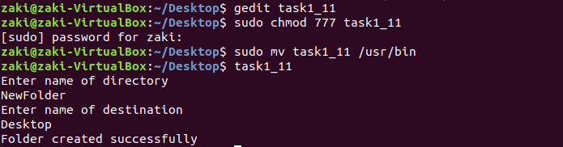

**Task 2.**

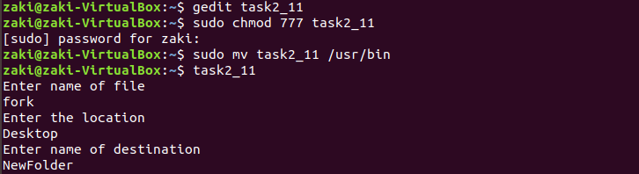

**Task 3.**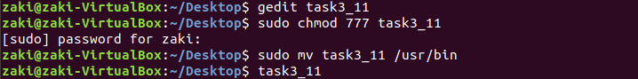

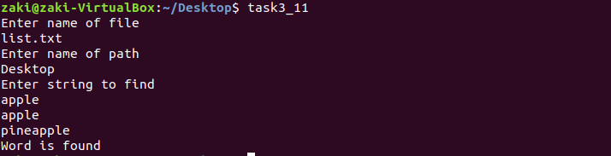

**Task 4.**

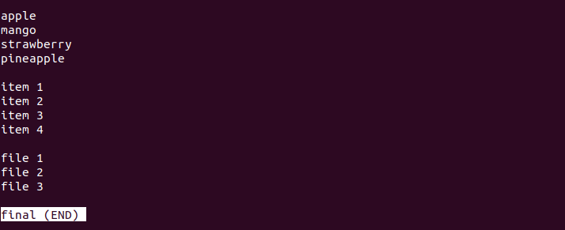

# **//LAB 12**

**

**

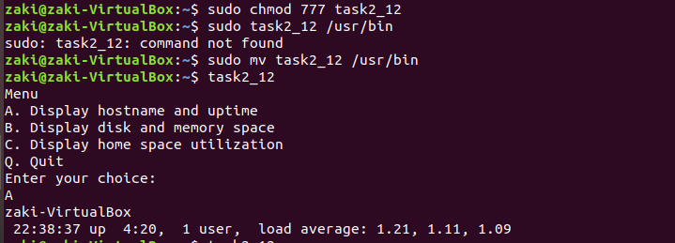

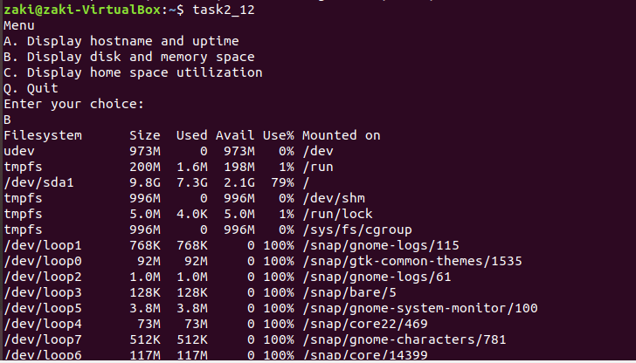

**Task 3.**

# **// LAB 13**

**





